# Game Specification

## Summary

Look out! You have found yourself lost in a cave system, with multiple rooms. A Wumpus lurks here – among other dangers. What’s a Wumpus? Ha, ha! You’ll find out while you’re sliding down its putrid gullet.

The object of this game is to find and kill the Wumpus within a minimum number of moves, before you get exhausted or run out of arrows. There is **only one** way to win: you must discover which room the Wumpus is hiding in, and kill it by shooting an arrow into that room from an adjacent room.

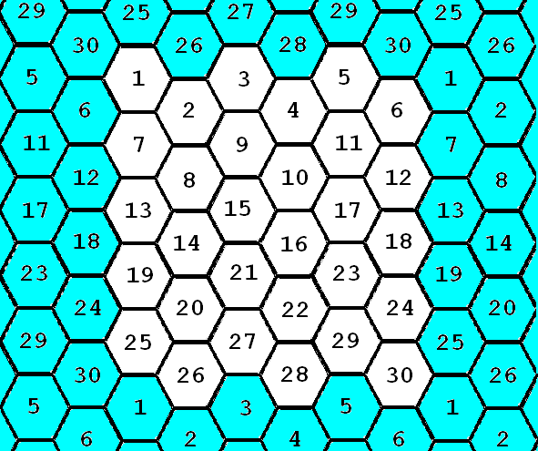

## The Cave

The Wumpus lives in a cave of 30 rooms. The rooms are hexagonal. Each room has up to 3 tunnels, allowing access to 1, 2 or 3 (out of 6) adjacent rooms. The preceding diagram shows the layout of rooms in the cave. The map wraps around such that rooms on the edges (white cells) have neighbors from the opposite edge (blue cells). E.g., the neighbors of room 1 are rooms 25, 26, 2, 7, 6, and 30, and you could choose to connect room 1 to any of these rooms. Observe how room 1 appears in 4 places in the diagram, due to the wrap-around.

You will need to create at least 5 different caves, i.e., different ways these rooms are connected, that the user can choose to play in. There should be no unreachable rooms in any cave.

## Hazards

Bottomless Pits - Two rooms have bottomless pits in them. If you go there, you fall into the pit. You can save yourself from crushing defeat and get out of the pit by getting at least 2 out of three trivia questions right. If you get out of the pit, you will be placed back where you started the game.

Super Bats - Two other rooms have super bats. If you go there, a bat grabs you and takes you to some other room at random. After the bats drop you into a new room, they will fly away to another random room in the cave.

No room will have more than one hazard. The Wumpus is not considered to be a hazard.

## Wumpus

The Wumpus is not bothered by the hazards (it has sucker feet and is too big for a bat to lift.) Usually it is asleep. Two things wake it up: your entering its room, or your shooting an arrow.

,fight for your life – answering ly to avoid being eatenItbeing en,. It might as many asit

If you shoot an arrow, the Wumpus sometimes runs to the next room in a random direction.

## The Player

Each turn you may move, shoot an arrow, purchase more arrows, or purchase a secret.

*Move:* You can move one room at a time.

*Shoot an Arrow:* You start the game with 3 arrows. You can shoot Arrow into any adjacent room connected via a tunnel. If the arrow enters the room with the Wumpus, it is killed and you win. If not, the Wumpus wakes up momentarily, and may move to a new room as described above. If you ever run out of arrows without killing the Wumpus, it will immediately take advantage of the situation by eating you (you lose).

*Purchase Arrows:* You can purchase 2 more arrows by getting at least 2 out of three trivia questions right.

*Purchase a secret:* You can purchase a secret by getting at least 2 out of three trivia questions right. The secrets range from not very useful to very useful. You can be told the room number where a bat lives, where a pit is, if the Wumpus is within 2 rooms of you, or the room number where the Wumpus is currently. However, you might also be told what room number you are currently in or the answer to a trivia question you have already been asked.

## Warnings

Whenever a hazard or the Wumpus is in an adjacent room, you are given a warning (or multiple warnings) about what’s nearby. The game will present these warnings (in any manner consistent with game interface):

Wumpus - I smell a Wumpus!

Bat - Bats Nearby

Pit - I feel a draft

It is up to you to determine which adjacent room(s) contain these items.

## Gold Coins and Trivia

On every turn that you move through a tunnel, you will be given a gold coin and be told a piece of trivia. There are 100 gold coins to collect in total. Every time throughout the game that you have to answer a trivia question it will cost you a coin to attempt to answer the question. Whether you get it right or wrong, it costs you one coin and you will never be asked that question again before the end of the game. If you ever run out of coins, you lose.

Conflicts occur at various times in the game, such as encounters with the wumpus. These conflicts are resolved in this specification by asking the user to answer trivia questions.

## Scoring

The object is to kill the Wumpus in as few moves as possible. If you do, you will get 100 points! Your score will be computed with the following equation:

*100 points – N + G + (5*A) + W*

N = number of turns

G = number of gold coins you have left

A = number of arrows you have left

W = 50 if you kill the Wumpus, 0 otherwise

The top 10 scores should be kept on file and include all of the information that made up the score (N, G, A and W) as well as the player’s name and which cave was played.

## Going Beyond the Spec

This spec describes the basic rules of the game, but you might not be satisfied with the game as described here. That’s OK – here are some other things you might think about!

**Test mode.** Building, testing and demonstrating your game is important. Consider having a mode that allows you to easily trigger each encounter in the UI. Not only will this make it easy for you to show off the game to your teacher, mentors and judges, but will save you lots of time when testing. Having a cave with a small number of rooms is a good way to do this. So is having some way to force the location of the Wumpus, hazards and food.

**Make it your own**. As you code to spec and get to the point of actually playing your game for the first time, you’ll get ideas on how to make it better. Take the leap. Treat the spec more as a starting point and a guide. Go ahead, paint outside the lines.

**Make it fun**. The spec leaves a lot to imagination, by choice. It is up to you to make the game engaging and fun. Ask yourself, is the game too easy / too hard / too annoying? Do you want to play it again? Is it awesome? If some rule is getting in the way of making it fun, change it, and tell us about it. 😊

**Tell a story**. Backstory. Heroes. Villians. Angst. Ethos. Emotion. Cut scenes. Visuals. Sounds. Think about stuff you like and infuse your game with a personality. What is a game if not a story and a challenge?

**Make it bigger. Harder.** Congratulations if you made a game that meets the spec, and still have time and energy to spare. Perhaps the questions the Wumpus asks are not dumb trivia but follow the same theme as the map, or draw the player into a deep dialog? Perhaps there are mind bending puzzles? Or good old-fashioned shoot-em-first? Want your own mini-game to resolve the battle with the Wumpus? Go ahead, run with it. We won’t stop you. But remember, walk first. Get some basic stuff working and then embark on your vision, so you have a safety net if you try something bigger than you realized.